Notification Letter for a service contract
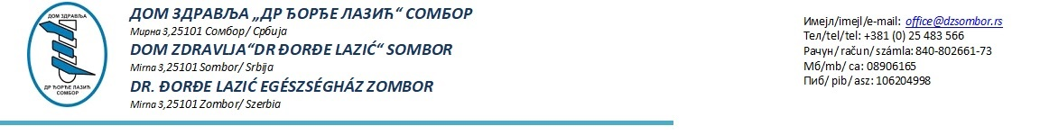

Branislav Filipović PR Agencija za poslovne
delatnosti Benedetto Cotrugli Subotica
Trg Sinagoge 1A, 24000 Subotica
PIB: 109530475
МБ: 64239660

Our ref: HR-RS00084 -03-02
Dear Branislav Filipović
ORGANIZING EVENTS for the project S.O.O.S., Identification number HR-RS00084 -03-02
The above contract will be awarded to you for the amount mentioned in your tender on the basis of the conditions stipulated in the tender dossier.
The contract value is RSD 6.419.000,00..
Please complete a new financial identification form if your bank account details have changed since those submitted with your tender.
For your information, please find below your scores as well as those for the next best tender. These scores are based on the average technical points awarded by the evaluators according to the award criteria. You will also find the composite results of the evaluation:
Composite Results
 | Tech score  x 0.80 | Fincl score x 0.20 | Overall score
Your tender | 80 | 20 | 100
Next best tender | - | - | -

The contract must be signed by the two parties by 25.12.2025 at the latest.
Please take note of the possibility – as described in the instructions to tenderers – that the tender procedure may – under certain circumstances – be cancelled by the Contracting Authority. In no circumstances will the Contracting Authority be liable for damages, whatever their nature (in particular damages for loss of profits) or relationship to the cancellation of a tender, even if the Contracting Authority has been informed of the possibility of damage. The publication of a contract notice does not commit the Contracting Authority to implement the programme or project announced.
Implementation of the tasks may not start before the contract is signed by both parties.

Yours sincerely,
Marijana Obradović

